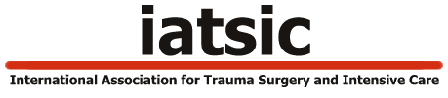

Course Candidate Application Form
Definitive Surgical Trauma CareTM Course
Definitive Anaesthetic Trauma CareTM Course
(Please check either one)
(Please type or print using black ink and send to DSTC-Japan@med.teikyo-u.ac.jp)
Application Date |  |  | Application sent by: |  |  | email |  |  |  | Fax |  | Post
Surname |  |  |  |  |  | Title
First name |  |  | Calling name for name badge
Business Address
Postal Address
Residential Address
Telephone: Home |  |  | Telephone: Business
Fax Number: Home |  |  | Fax Number: Business
Cell Phone: |  |  | Email:
Medical Registration No. |  |  | Nursing Registration No.
I.D. or Passport No. |  |  | Nationality
Special Diet Request
Qualifications |  |  | University degree and Date
Highest Surgical Examination (Board Certification of Surgery) |  |  |  |  | Date passed
ATLS® (or convertible course such as JATEC) successfully completed |  |  |  |  | Date
Summary of experience over last three years
Residency performed at
Current appointment
Reasons for DSTCTM / DATCTM Application
Office Use only
Date Received | Date acknowledged |  |  | Payment received |  |  | Course allocated

